# 2.Overall description

This section gives an overview of the Game “Battleship” to be developed. For this, it is described, how the user will interact with the game and its key features using Use Case and Sequence Diagrams.

## 2.1 Product Perspective

As shown in Figure 1, The game interact with the Player and computer, however that depends on What mode is selected. If player select “Single player mode” then the game can be played with player and computer, if the player Select “Multiplayer mode” then the game will interact among two players instead of one player and computer.

Player Game Computer

Figure : Game Environment

## Product Functions

In this subsection, the product functions are described through the main use cases of the system as shown in Figure 2. And how it is going to operate in Figure 3.

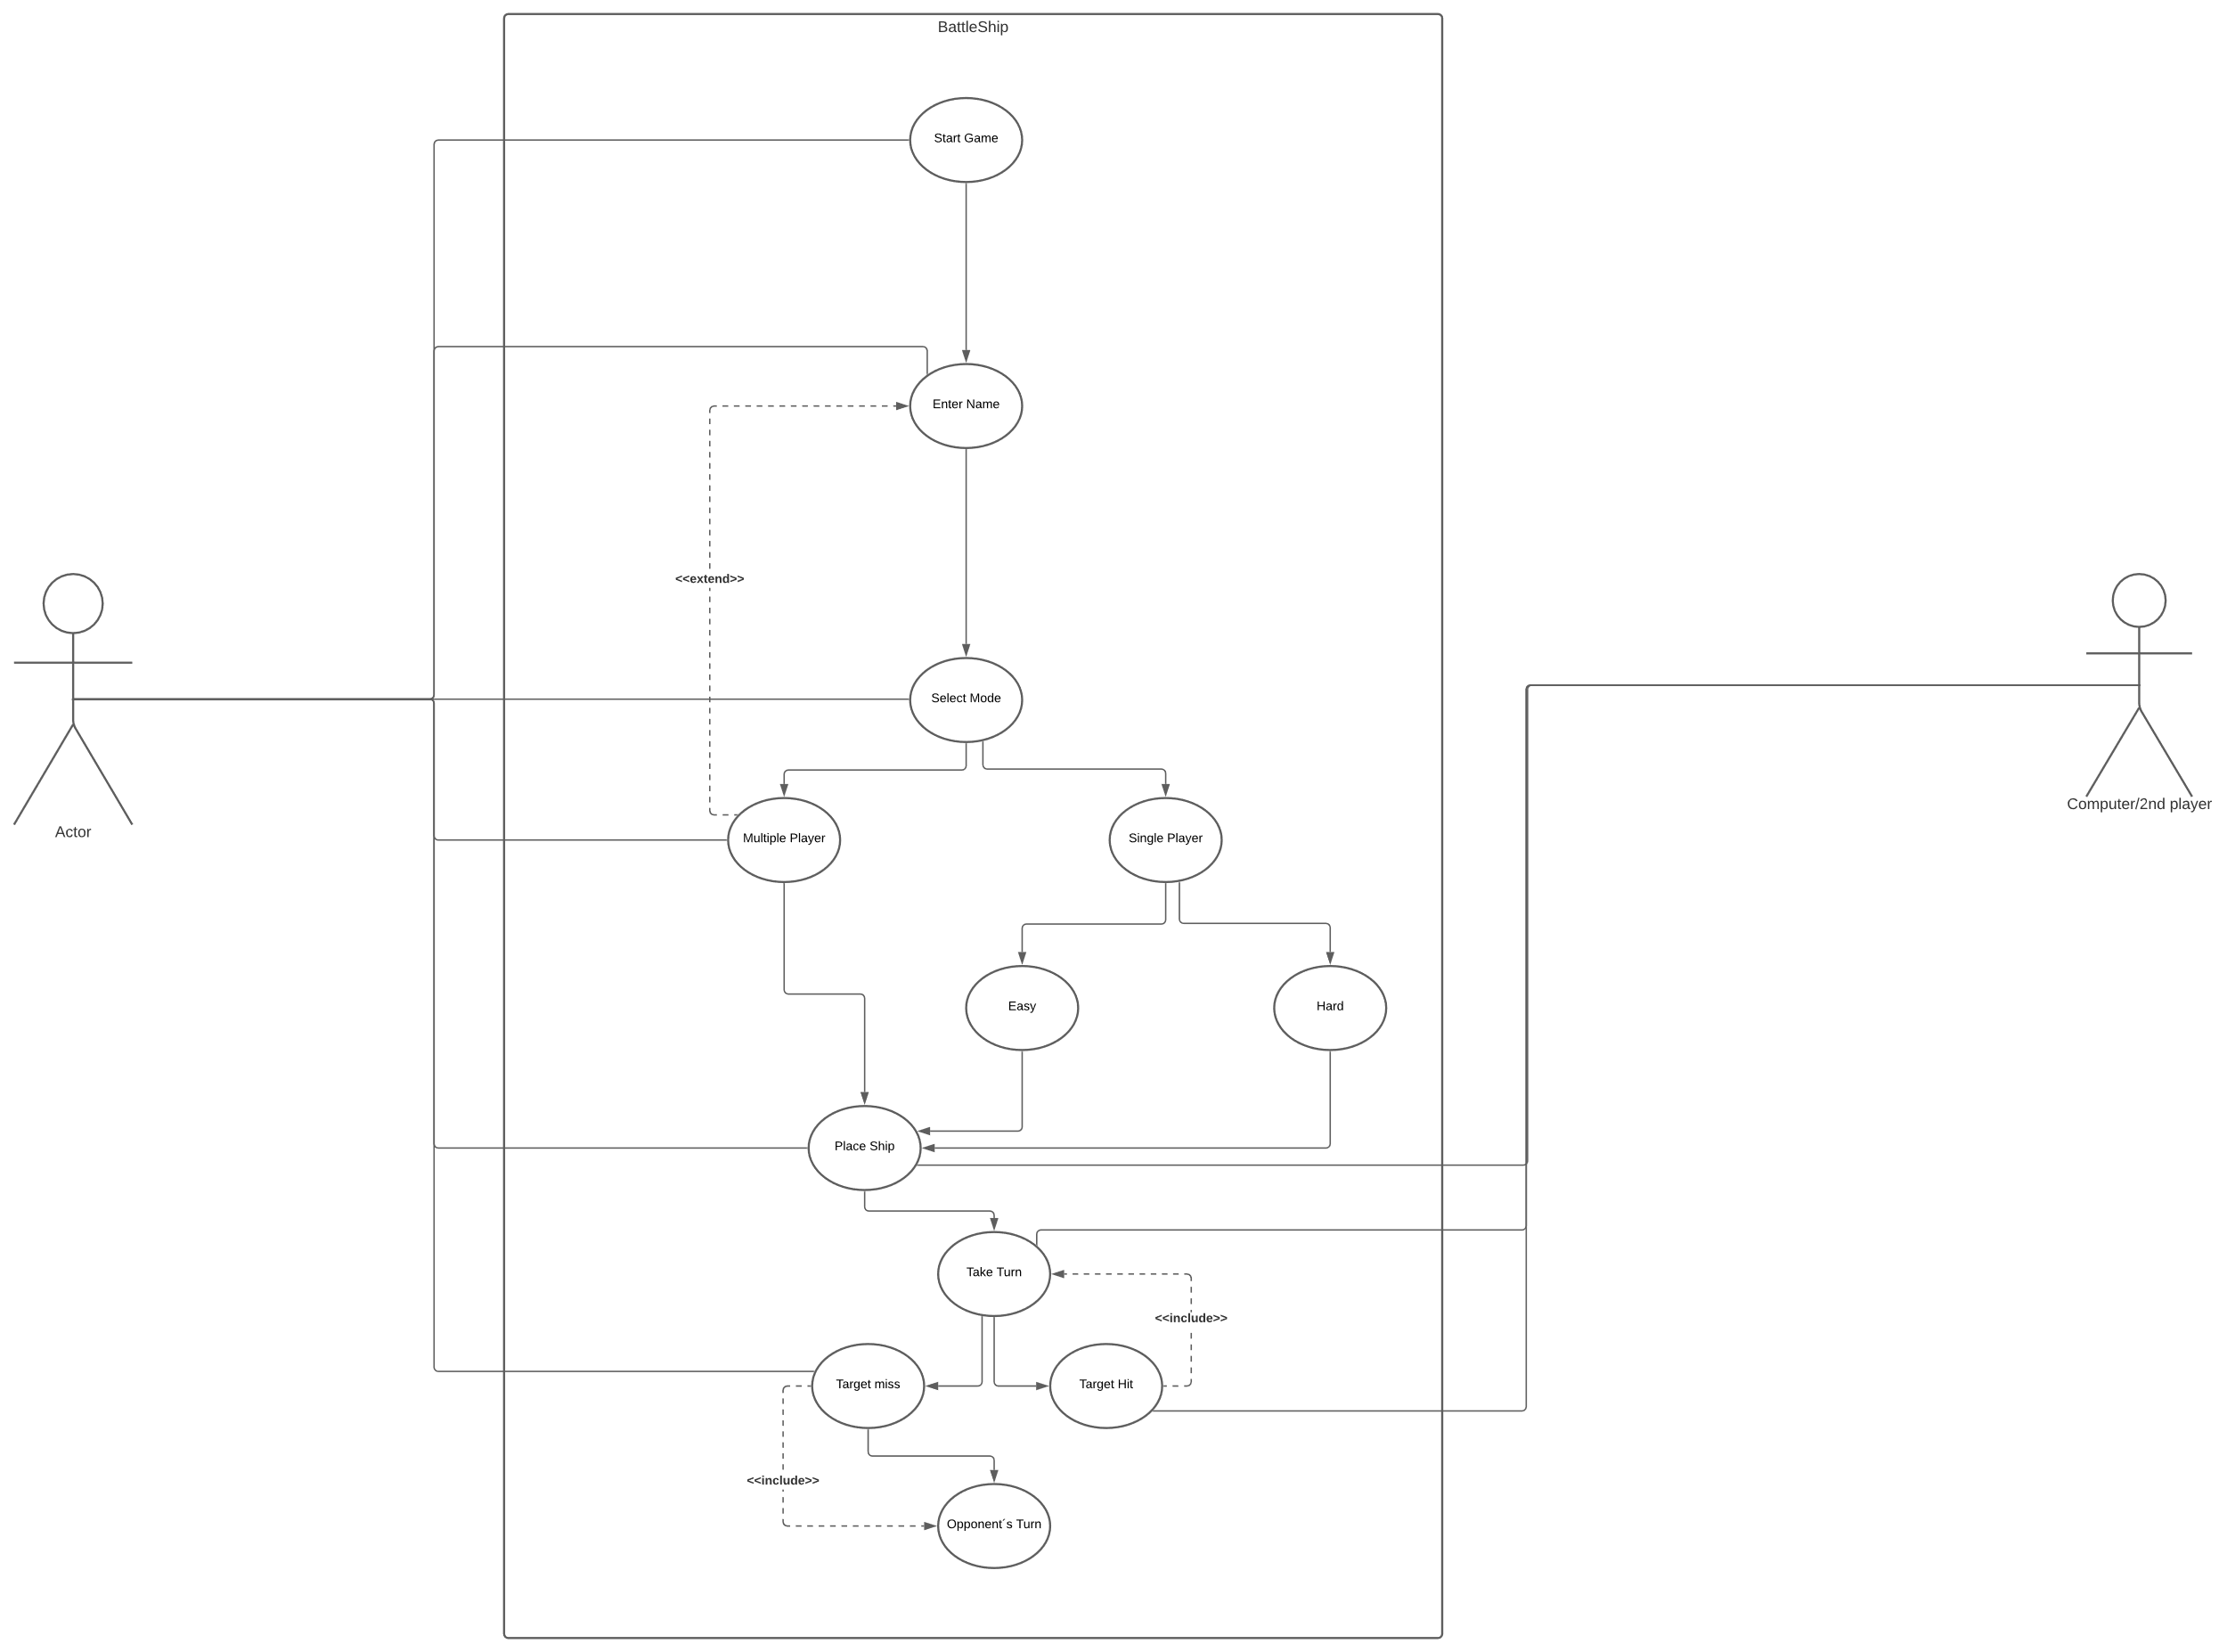

Figure : Battleship Use Cases

In the remainder of this subsection, a detailed description of each use case is provided.

Start Game:

This is the very first action that will be expected by the user. Which will start the game as new game.

Name:

Here player will have the option to Create a name for themselves, as for computer it will have a default name “Lightning Torpedo”

Selecting Mode:

This is the most important part of the game since based on this action player can decide who will be his opponent.

Place ship:

In this section player will place his ship in the battleground as he wish. Here player can place the ship as “+” shape not “x” shape. And the ships should have at least one block gap.

Take Turn:

Taking turn Starts with Letting player 1 guess first, if he hit the target he can guess again. However, if he misses then it goes to the opponent and the opponent starts guessing. Similarly if he hits the target, he can guess again or else, he loses his turn. The game continues taking turn until one sunk all the ships opponent has!

In figure 3, the sequence diagram shows how the actions take place in the game in sequence manner thus the name sequence Diagram.

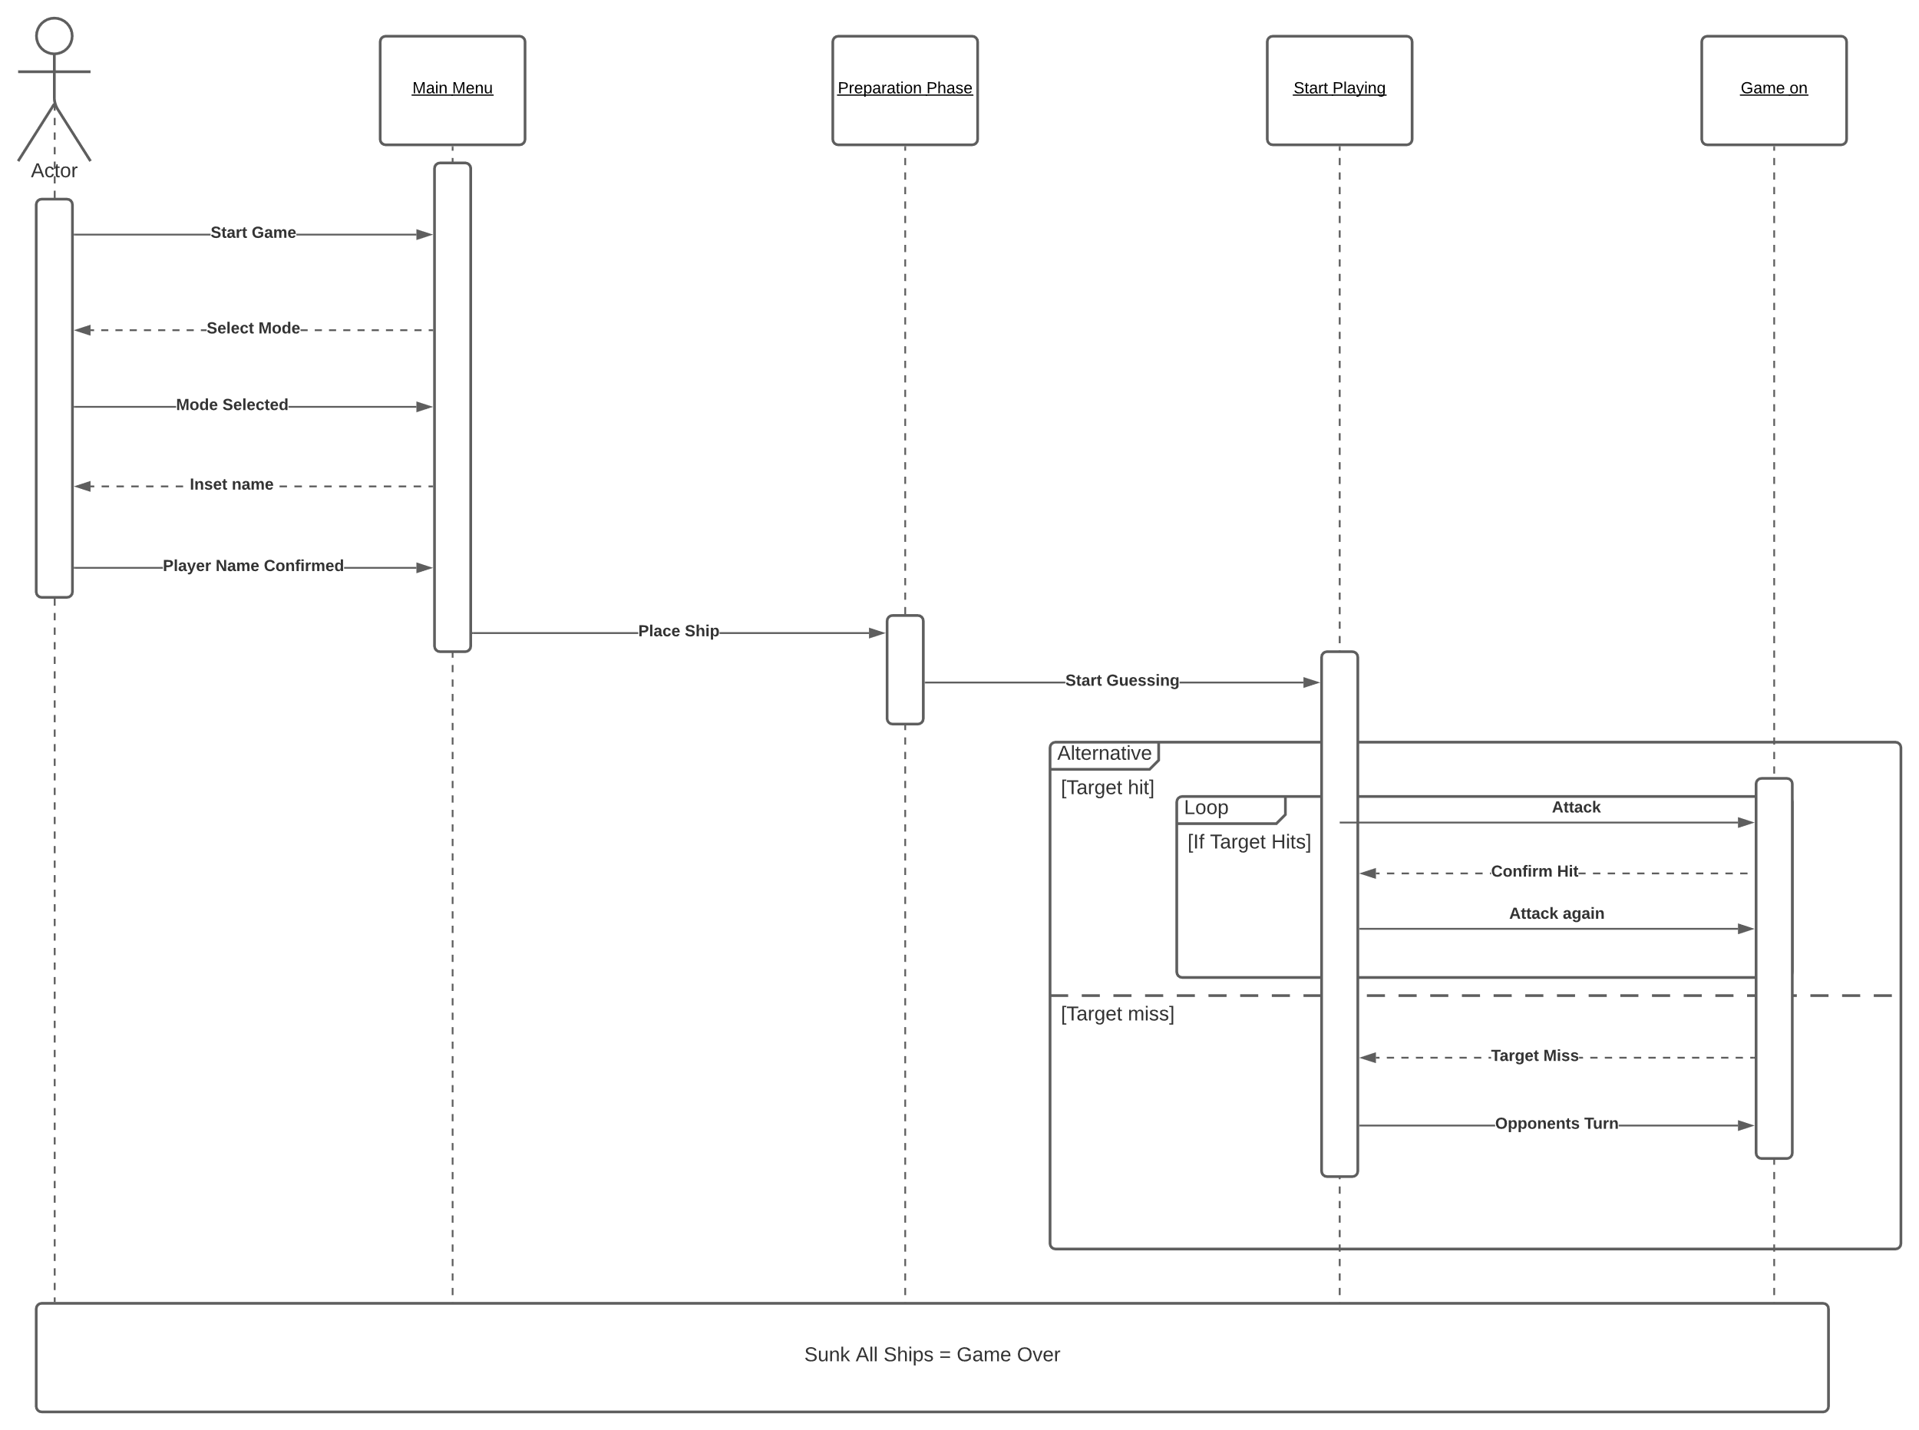

Figure 3: Battleship Sequence Diagram

Here we have actor and 3 objects labeled as “Main Menu, Preparation Phase, Start Playing & Game on”

Main Menu:

The main menu is the first interface that the user interact with. In this section player Choose his/her desired play mode, after that he/she chooses a name for them. After completing this part he moves to the next one which is “Preparation Phase”

Preparation Phase:

Here player have the option to choose their desirable slot to place their ships. Once done they move to the next section labeled as “Start playing”

Start Playing:

Here player guess a location of opponents ship-yeard, if he/she hits the target, he/she is allowed to guess again and it continues until they miss one. If they miss to hit a location of the ships, the opponents will have the option to guess. This continues until one manage to hit the location of all the ships and sunk them.

In that case the game will be “OVER”

## User Characteristics

The following user types have been identified:

Regular Users:

For the regular user there any restrictions, the game can be played by anyone with any age group. No technical expertise is necessary.

System:

If the player choose to play single player mode, his/her opponent will be computer, For that computer will follow some kind of algorithm.

## Constraints

The system shall be implemented using “C” Programming language.

## Assumptions and Dependencies

None